Southmoor Academy A Level Media Studies and Film Studies – Bridging Work
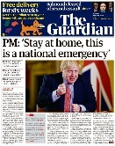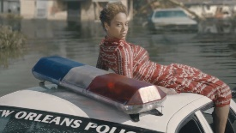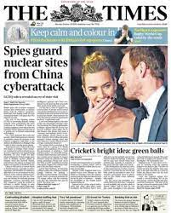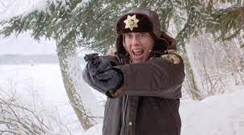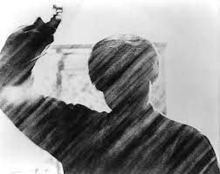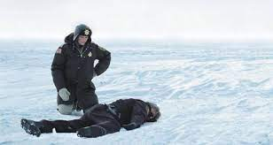
Hi Year 11s, welcome to the work we’ve created for you to bridge the gap between GCSE and A Level Media Studies and Film Studies. Both Media and Film are exciting and rewarding A Level subjects and we consistently get fantastic results in both subjects at 6th Form. You’ll be provided with resources that tell you more about the structure of the two courses as part of the induction process and at the start of your courses in September, this resource is purely devoted to the tasks we want you to do to bridge the gap between GCSE and A Level.

Media Studies:
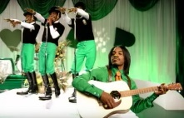
Music Videos: One of the first units we study for A Level Media Studies is music video. It would be useful for you to have some knowledge of this subject before you start your A Level Media course.

TASK:
- What do you know about music videos? What are some of their codes and conventions? Think about some of the following things:

- Purpose.
- Length.
- Content.
- Pace of editing (how quickly the director will cut from shot to shot).
- Who they are aimed at.
- Where you can watch them.
- Narrative (if/how they tell stories).
TASK:
- Choose a music video you particularly like, use the following questions to analyse it. You should aim to write about a page:

- Who is the intended audience and how do you know?
- What is the purpose of the video?
- How are the following elements of what we call “media language” used in the video
  - Colours and lighting.
  - Camera angles.
  - Shot types (what kinds of shot types – close ups, wide shots etc. have been used at different stages of the video and why).
  - Camera movement.
  - Lighting.
- Who is being represented or shown in the video? How are they being shown and how are we supposed to feel about them – admiration? Hatred? Desire? Jealousy?!
- In your own words summarise what you like about the video

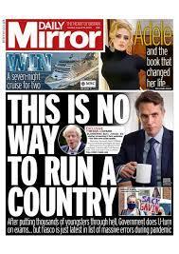
Newspapers:
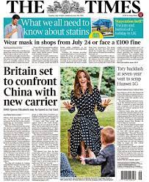
Another significant topic we study for A Level Media Studies is newspapers. The newspaper industry faces some significant problems in the early 21st century and it might seem that people don’t read newspapers any more but newspapers play a vital role in holding powerful people, including politicians, to account. They have had to adapt to a rapidly changing media world. Again, it would be useful for you to have some understanding of newspapers before you start your Media Studies A Level.
TASK:
- What is the difference between and tabloid and broadsheet newspaper? You might want to think about the following things:
- What are the biggest selling national broadsheet and tabloid newspapers in the UK?
- What are the differences between them in terms of presentation/layout?
- Who is each type of paper aimed at?
- What kinds of stories does each type of paper focus on?
- Who owns which papers? Which papers are tabloids, which are broadsheets?

TASK:
- What problems might newspapers be facing in the contemporary media age (I’ll give you a clue, think about the impact of the internet and digital technology and how this has changed the way people use the media).

TASK:
- It would be very useful if you could get into the habit of using broadsheet newspaper apps/websites on a regular basis. Broadsheet newspapers regularly publish articles or produce content about developments, debates and issues relating to the media. Unfortunately many broadsheet newspapers are now behind Paywalls, meaning you have to pay a subscription to read their content. The Guardian and The Independent are free to use, other broadsheet newspapers are available though:

The Guardian: https://www.theguardian.com/uk
The Independent: https://www.independent.co.uk/
The Times: https://www.thetimes.co.uk/
The Telegraph: https://www.telegraph.co.uk/

Film Studies:
Film is a fantastic separate A Level, that I hope many of you will have signed up to do, it also comes in to the A Level Media Studies course, so whatever your choices it is useful to have some knowledge and understanding of the medium of film.

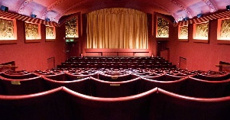
- Watching Films: Could there be a nicer task for your teachers to ask you to do between now and September? One of the most important things you can do for A Level Film studies is to simply watch films and enjoy watching them. There are obvious services you can use to use to watch films at home. Amazon Prime Video and Netfix are pumping huge amounts of money into the creation of original TV and Film content – with Netflix fast becoming a major producer of feature films. However, neither service will give you access to all the set films we have to study or to the range of films you might be advised to watch or want to watch yourself. Have a think about signing up to one of the following services – or simply have a look at the ones that are free:

Cinema Paradiso:
This does things the old fashioned way and is very similar to a service your parents might remember called LoveFilm. You have to sign up to them for about £5 a month and then make a list of all the films you want to watch. They’ll then send the films on your list through to you on DVD by post. Once you’ve finished watching a film you post it back to them and they send you the next one on your list. Apart from the newest Netflix releases, they have virtually every film ever made available. It’s great. https://www.cinemaparadiso.co.uk/
BFI Player:
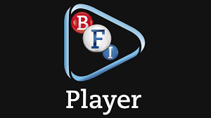
The British Film Institute’s BFI Player is a streaming service that provides users with access to a huge range of films including those that are more unusual or difficult to find elsewhere. They also provide a lot of extras including commentaries on films. Some content is free; you can also subscribe to them or just use them to stream films for a fixed fee either as one off rentals or for unlimited viewing: https://player.bfi.org.uk/
Mubi:
Mubi is a subscription film streaming service with a difference. Instead of giving you access to an unlimited range of films they hand pick a few films each week for their subscribers to watch – the idea being that you discover quality films, filmmakers and film movements you might not come across otherwise. £5.99 a month for students: https://mubi.com/student
Talking Pictures:
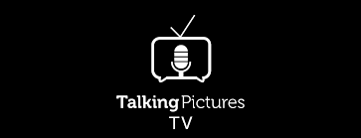
This one’s completely free! Talking pictures is a TV channel run by film lovers that only shows classic films – it’s a gateway to an amazing world of film. Available on Virgin 445, Freesat 306, Freeview 81, Sky 328, https://talkingpicturestv.co.uk/

Going to the Cinema:
Watching films at home is fine but it doesn’t compare to the experience of seeing a film in a cinema, something we’ve all been deprived of for the last year. How about trying some of the following cinemas?
We’re all desperate to get back to the cinema! When you’re able to you might want to explore some of the following:
- Picturehouse Cinemas – Brixton, Clapham, West Norwood, Dulwich (https://www.picturehouses.com/blog) show more obscure films alongside blockbusters. They run two slots that are particularly useful to Film students, Vintage Sundays (where – as the name suggests, they show classic films from the past) and Discover Tuesdays where they run seasons that explore the work of significant directors or film movements. Screenings during these slots are also considerably cheaper than usual – tickets also tend to be cheaper on a Monday.
- BFI – The British Film Institute cinema runs seasons of films that focus on key directors or film movements. It is no ordinary cinema and is well worth knowing about and visiting (https://whatson.bfi.org.uk/Online/)
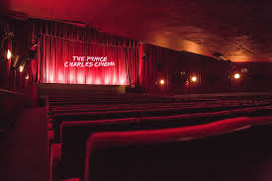
- The Prince Charles Cinema – A London institution – cheap tickets, shows films that have finished their runs in other cinemas and older classic films. https://princecharlescinema.com/PrinceCharlesCinema.dll/Home

TASK:
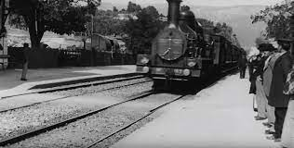
- Film is only just over 100 years old, it has a pretty short history as a medium. This makes it relatively straightforward to get an understanding of its history and how it has developed. Use the “Teach Yourself Film” resource and your own research to create a timeline that charts every decade of film history from the 1890s to the 2010s. It should include:
- Key developments in film history: the first film ever made, the introduction of sound, the introduction of colour film etc.
- Key films from each decade
- Key directors from each decade
- Key broader historical events of each decade

TASK:
- Early in the A Level Film Studies course we will study a film called No Country for Old Men by Joel and Ethan Coen, more commonly known as the Coen Brothers. You will need to do some research into them, consider the following questions:

- Who are they?
- What films have they made?
- What are their films about?
- When did they start making films?

TASK:
- Watch Fargo, made in 1996 by the Coen brothers (https://www.amazon.co.uk/Fargo-Frances-McDormand/dp/B00HDCMZHY/ref=sr_1_1?crid=2IP6RQVPQBJZF&dchild=1&keywords=fargo+film&qid=1623752322&sprefix=Fargo%2Caps%2C149&sr=8-1 don’t get it confused with the TV series that has the same title). Write a single page review of the film that summarises what you feel about it and what you think the Coen Brothers might be trying to do with the film. You might want to think about the following:

- Is the film different to other films you may have watched produced from within the American film industry. If so how?
- What can you say about:
  - The film’s approach to narrative (how it tells a story.)
  - Performance.
  - Use of music.
  - Pace of action and pace of editing.
  - Your own personal opinions about the film.

EXTENSION TASKS:
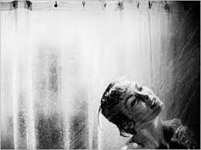
- Watch Alfred Hitchcock’s 1960 film Psycho, we will study it early in the course, it would be useful to watch it before you start.

- Because of the lockdown many academics and institutions have made excellent Film/Media courses and resources available for free, you might want to have a look at some of this and take advantage of it:

- The 22 Rules of Storytelling from Pixar - should be of use for screenwriting:
https://nofilmschool.com/2013/12/pixars-22-rules-of-storytelling-free-ebook

- Every Frame a Painting is a series of video essays on different aspects of film form and how they’re used by filmmakers:
https://m.youtube.com/user/everyframeapainting/featured

- Sundance Film Festival have made many of their (usually very expensive) online filmmaking workshops available for free - give them a look, a great opportunity:
https://collab.sundance.org/master-classes?utm_source=fb&utm_medium=feed_org&utm_campaign=free_master_classes&fbclid=IwAR0KIcsIR5Nchvmy3UW4fPlxnOclc1JEk83KS3CpnYEkOe4wCBUvOxbdXu0

- Mark Cousins - 40 Days to Learn Film
Mark Cousins is a renowned film historian, his two hour video lecture “40 Days to Learn Film” is accessible and does what it says on the tin:
https://vimeo.com/399407221

Futurelearn have collaborated with a number of renowned institutions (including the BFI) to create a range of excellent free online Media and Film related courses, highlights below:

- Gender Representation in the Media:
https://www.futurelearn.com/courses/gender-and-the-media

- Introduction to Screenwriting:
https://www.futurelearn.com/courses/screenwriting

- National Film and Television School - Explore Filmmaking: From Script to Screen:
https://www.futurelearn.com/courses/explore-filmmaking

- Film Distribution - Connecting Films With Audiences:
https://www.futurelearn.com/courses/film-distribution

READING LIST:
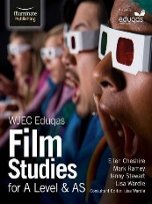
Film Studies: Do you need to read lots of books to start studying Film at A Level? Not necessarily. However, if you want an introduction to the course and want to start to get a feeling for the history and conventions of film some of the following might be useful. Look out for second hand copies on Amazon or elsewhere:

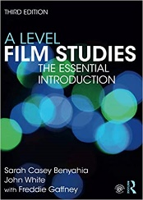
- There is a useful textbook published by Illuminate Publishing that covers the course WJEC Eduqas Film Studies for A Level & AS. It is well worth investing in.
- The textbook A Level Film Studies: The Essential Introduction is perhaps even better, covering a wide range of film movements and periods in film history.
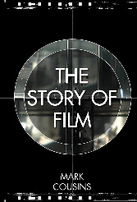
- There are three older textbooks that are still quite useful (and can be bought relatively cheaply secondhand on Amazon or elsewhere), AS Film Studies and A2 Film Studies by Sarah Casey Benyahia and Freddie Gaffney and AS Film Studies by Jo Harland and Nick Timmons.
- The following books are useful for getting an insight into film history and are highly recommended: The Story of Film: A concise history of film by Mark Cousins, History of Film by David Parkinson and A Short History of Film by Wheeler Winston Dixon and Gwendolyn Audrey Foster.

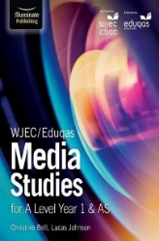
Media Studies: There are two useful textbooks published by Illuminate Publishing that cover the course WJEC/Eduqas Media Studies for A Level Year 1 & AS https://www.amazon.co.uk/WJEC-Eduqas-Media-Studies-Level/dp/1911208101/ref=sr_1_2?keywords=eduqas+a+level+media+studies&qid=1568016703&s=gateway&sr=8-2

and WJEC/Eduqas Media Studies for A Level Year 2 & A2
https://www.amazon.co.uk/WJEC-Eduqas-Media-Studies-Level/dp/191120811X/ref=sr_1_1?keywords=eduqas+a+level+media+studies&qid=1568016703&s=gateway&sr=8-1

Enrichment and Work Experience Opportunities:
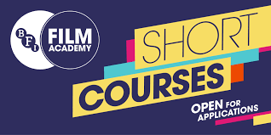
The BFI Future Film Academy:
The BFI (The British Film Institute) runs a fantastic range of courses run by Media and Film industry professionals for 16-19 year olds. Their main page can be found here https://www.bfi.org.uk/education-research/5-19-film-education-scheme-2013-2017/bfi-film-academy-scheme/bfi-film-academy-uk-network-programme and https://www.bfi.org.uk/education-research/bfi-film-academy/bfi-film-academy-specialist-residential-programme.
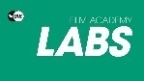
They also run a range of online courses and workshops that are well worth signing up to:
BFI Academy Labs:
FREE monthly Saturday events for 16-25 year olds - https://whatson.bfi.org.uk/Online/default.asp?BOparam::WScontent::loadArticle::permalink=bfifilmacademylabs&BOparam::WScontent::loadArticle::context_id=
BFI Academy Scene:
Live online interviews with young filmmakers every Thursday evening. FREE for 16-25 year olds who can submit questions for the filmmakers. A great opportunity to see others’ work and make connections: https://whatson.bfi.org.uk/Online/default.asp?BOparam::WScontent::loadArticle::permalink=scene2018&BOparam::WScontent::loadArticle::context_id
These courses are either free or very cheap, give you high quality media and film production training, are next to free and would look great on your CV or UCAS application. Here’s what the BFI say about their Film Academy courses: “Are you 16-19? Passionate about film? Want a career in the film industry? If so, the BFI Film Academy is for you. This course offers you the chance to be part of our future film industry.”

In addition to the BFI courses and workshops there are a range of other organisations providing training and work experience in London, these include:

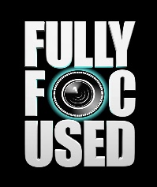
Fully Focused Productions:
Fully Focused Productions is a charity that runs a range of programmes to help young people enter the film industry. They run a range of FREE online filmmaking masterclasses and sessions Follow their socials (@ukfullyfocused) for details of upcoming workshops and masterclasses on everything from sound to editing, cinematography, production and much more. https://www.fullyfocusedproductions.com/

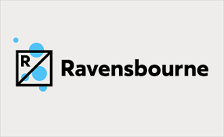
Ravensbourne College
Ravensbourne College in Greenwich run one of the most prestigious Film and TV production courses in the country. They regularly offer a range of free production workshops to secondary school students. The links below are for last year’s courses, if they are out of date try googling “Ravensbourne College workshops”, “Ravensbourne College school workshops” or “Ravensbourne College holiday workshops”,
https://www.ravensbourne.ac.uk/events/masterclasses/february-half-term-film-workshop
https://www.ravensbourne.ac.uk/information/schools-and-outreach/saturday-clubs-and-holiday-schools?fbclid=IwAR1wthSWBvrhjHzjgMkCdqEFQWfdntBWY_aFTFRnOYYpv4sQnp8WeEbTSMUP
https://www.ravensbourne.ac.uk/events/saturday-club

