Year 12 Transition Work – Maths - AS Pure Chapter 1

All of your work should be completed on file paper with full working shown.
Start each exercise on a new sheet of paper and make sure all questions are clearly labelled and well set out.

This work will be collected in and marked by your teacher. We will ask you to resubmit any questions that are missing or incomplete.
Exercises 1A – 1F will be due in by the end of the first week back (Friday 9th September)
Mixed Exercise 1 will be due in by the end of the second week back (Friday 16th September)
This is to allow for feedback on your exercises 1A-1F to be given and to give you the opportunity to seek help in school for any topics you have found particularly difficult.

Section 1.1 – Index Laws
Watch the video entitled Ex 1A using the link below…
https://youtu.be/3Oyw7d2PiMg
…and then attempt the following questions from the exercise below.
Question 1 – left hand column – parts a, d, g, j, m, p
Question 2 – left hand column – parts a, d, g, j, m, o, r, t
Question 3 – all parts
If you think you need more practice at this section then feel free to complete the other parts of the questions too!
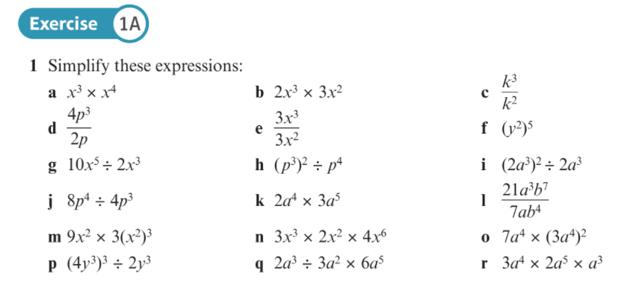
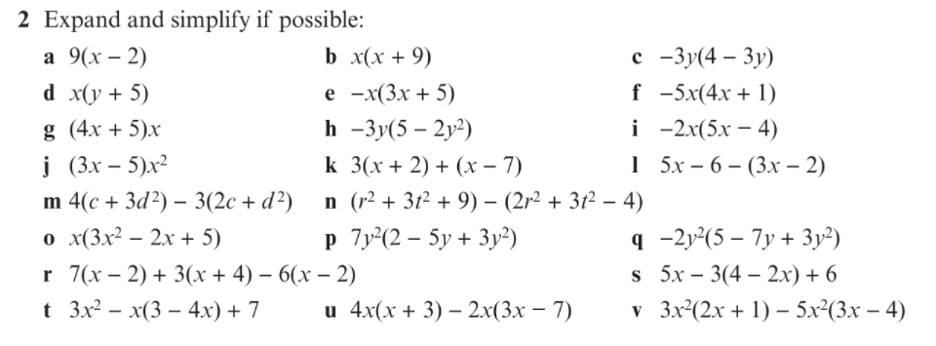
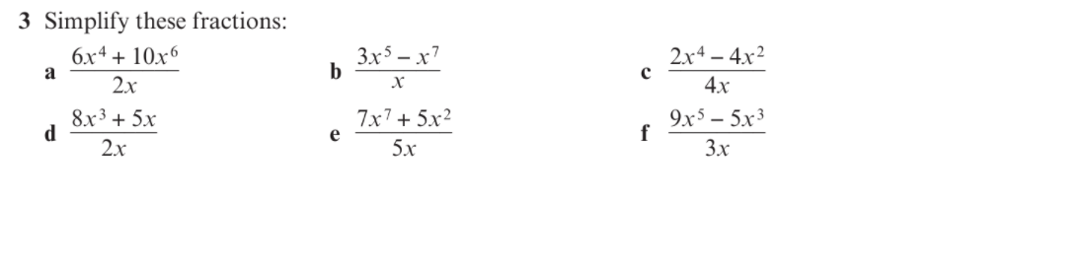

Section 1.2 – Expanding Brackets
Watch the video entitled Ex 1B using the link below…
https://youtu.be/mUoJDPr1LcA
…and then attempt the following questions from the exercise below.
Question 1 – left hand column – parts a, d, g, j, m, p
Question 2 – left hand column – parts a, d, g, j, m, p, s, v
Questions 3 - 5 – all parts
If you think you need more practice at this section then feel free to complete the other parts of the questions too!
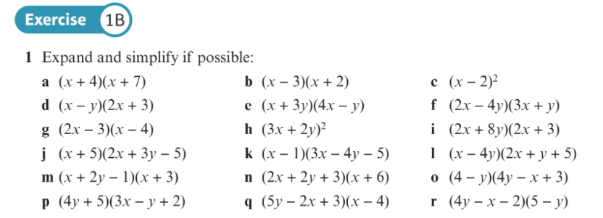
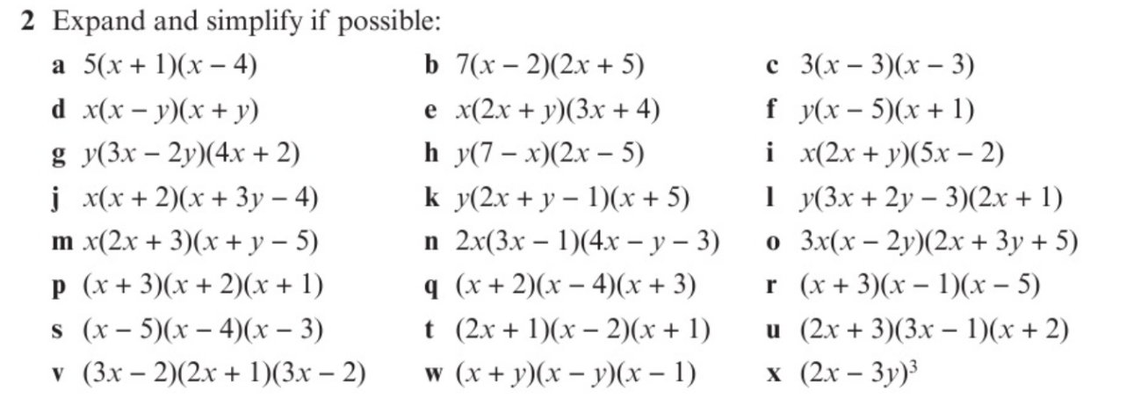
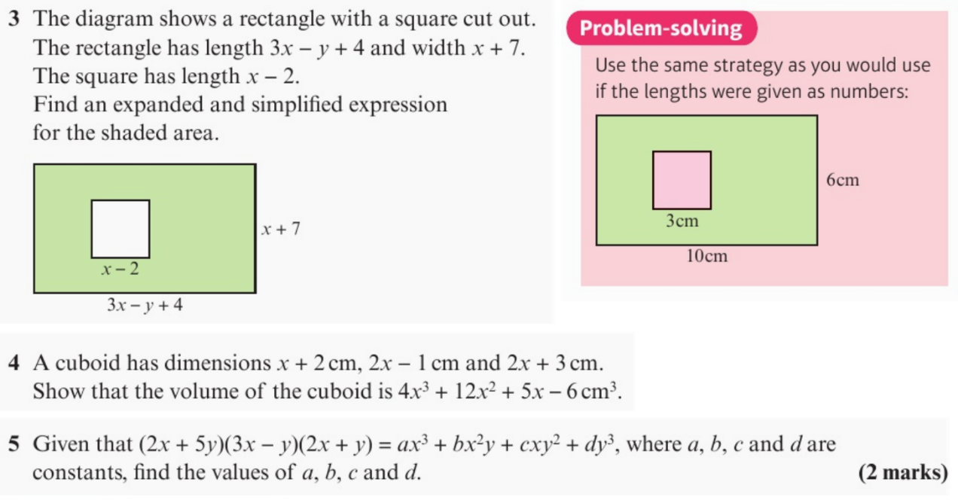
Section 1.3 – Factorising
Watch the video entitled Ex 1C using the link below…
https://youtu.be/XXKveclZxFQ
…and then attempt the following questions from the exercise below.
Question 1 – left hand column – parts a, d, g, j, m, p, s, v
Question 2 – left hand column – parts a, d, g, j, m, o, q, s, v
Question 3 – all parts
Questions 4 and 5
If you think you need more practice at this section then feel free to complete the other parts of the questions too!
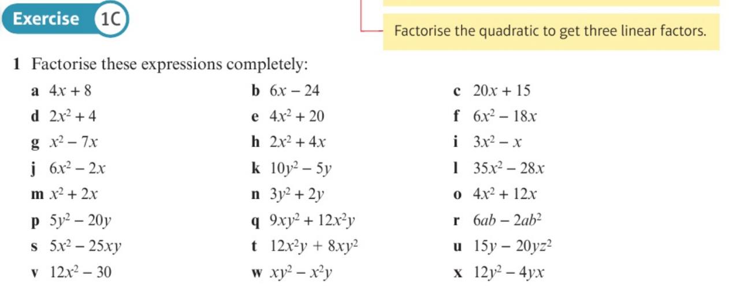
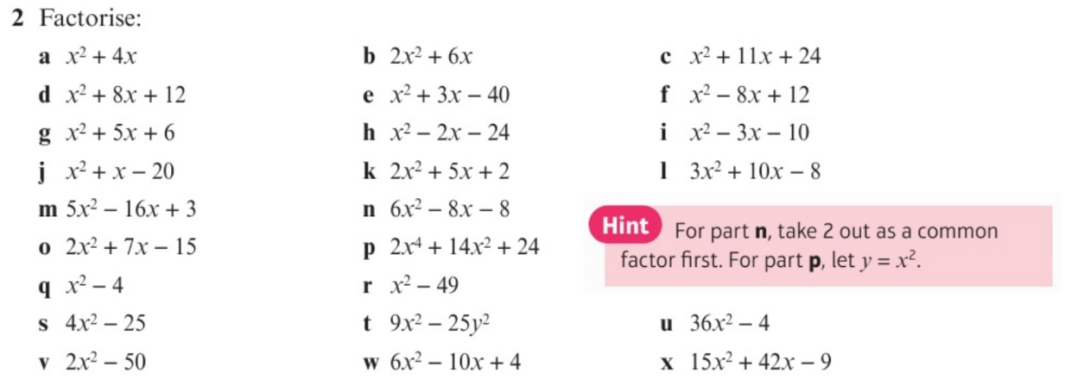
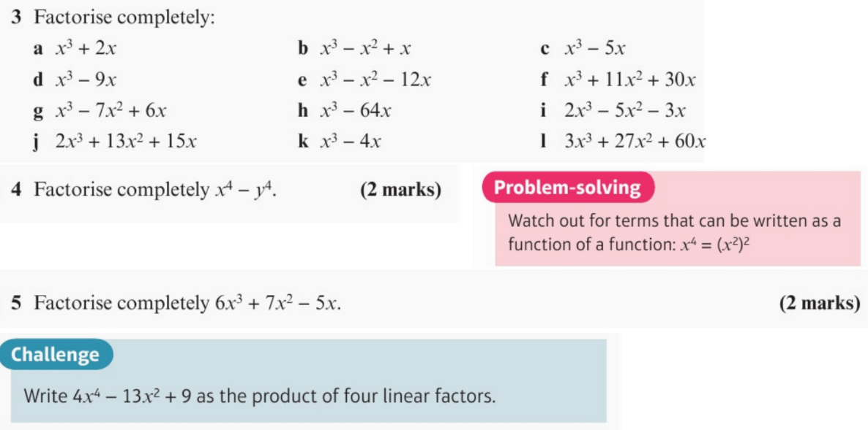
Section 1.4 – Negative and Fractional Indices
Watch the video entitled Ex 1D using the link below…
https://youtu.be/EvkjjT19lNI
…and then attempt the following questions from the exercise below.
Questions 1 – 5 – all parts
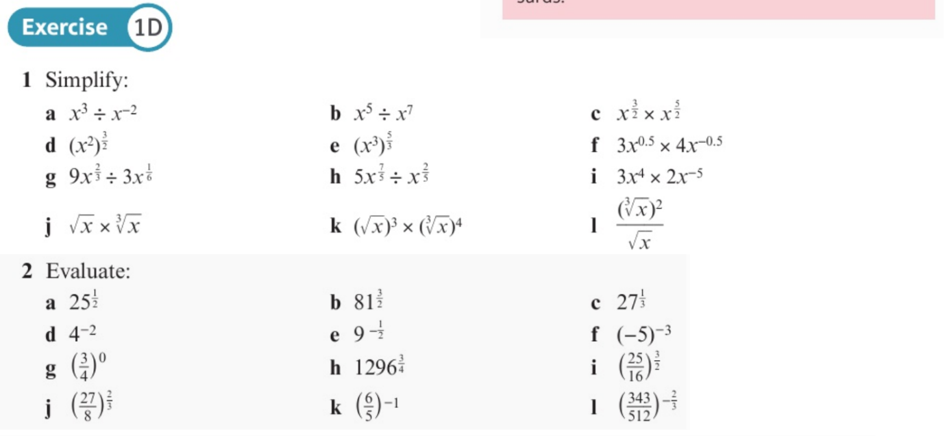
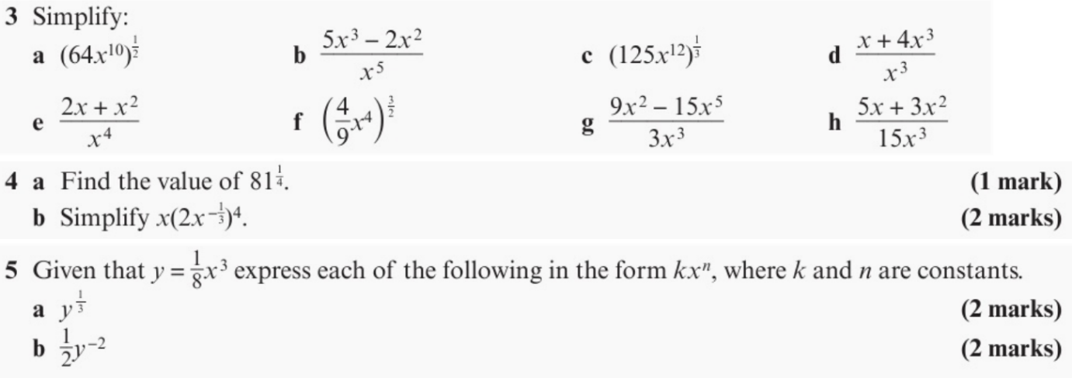

Section 1.5 – Surds
Watch the video entitled Ex 1E using the link below…
https://youtu.be/cuTxG2GzqTE
and then attempt the following questions from the exercise below.
Question 1 – parts a, c, e, g, I, k, m, o
Question 2 – parts a, c, e, g, i
Question 3
If you think you need more practice at this section then feel free to complete the other parts of the questions too!
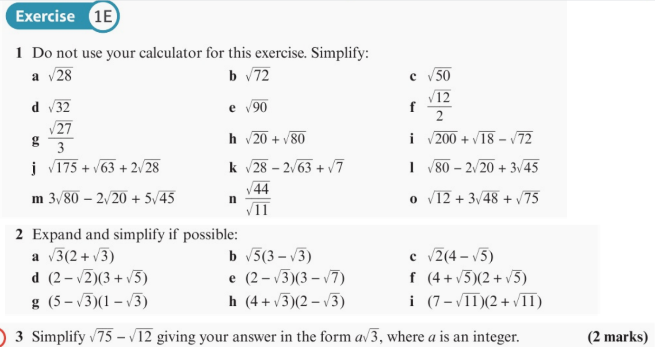

Section 1.6 – Rationalising Denominators
Watch the video entitled Ex 1F using the link below…
https://youtu.be/jbICCHtlSYY
…and then attempt the following questions from the exercise below.
Question 1 – parts a, c, e, g
Question 2 – parts a, c, e, g, I, k, m
Question 3 – parts a, c, e
Question 4
If you think you need more practice at this section then feel free to complete the other parts of the questions too!
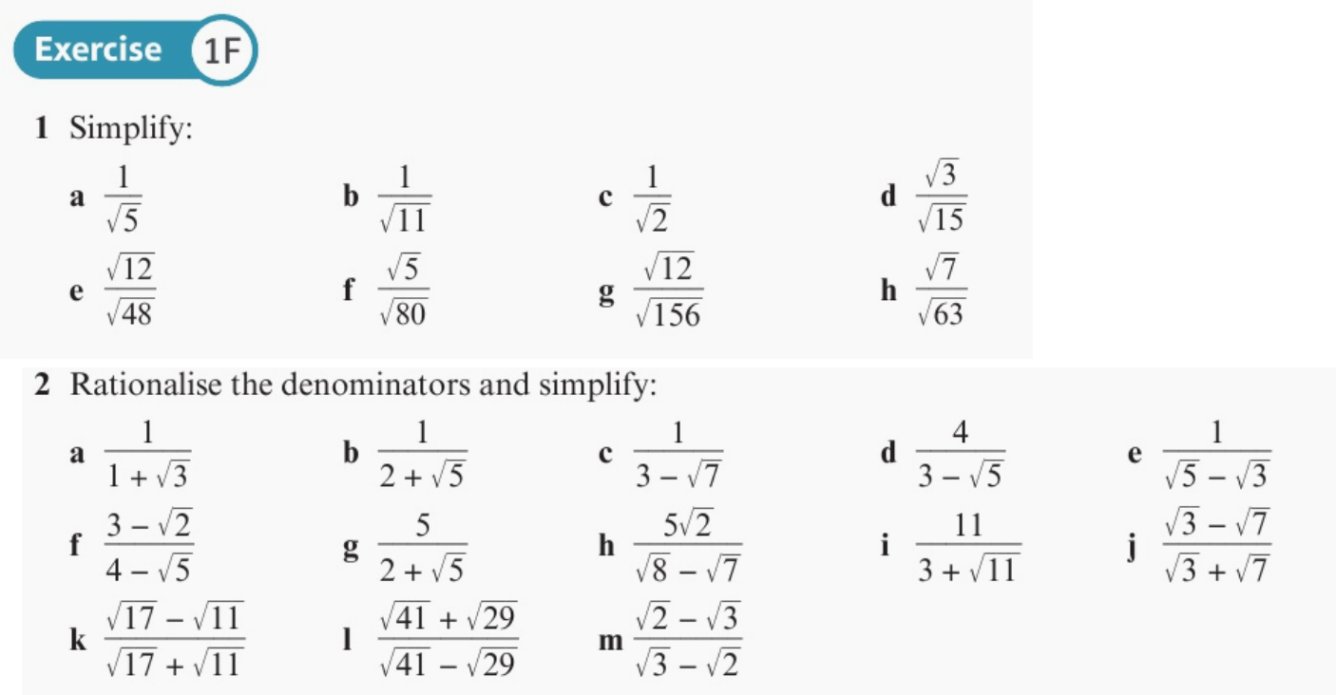
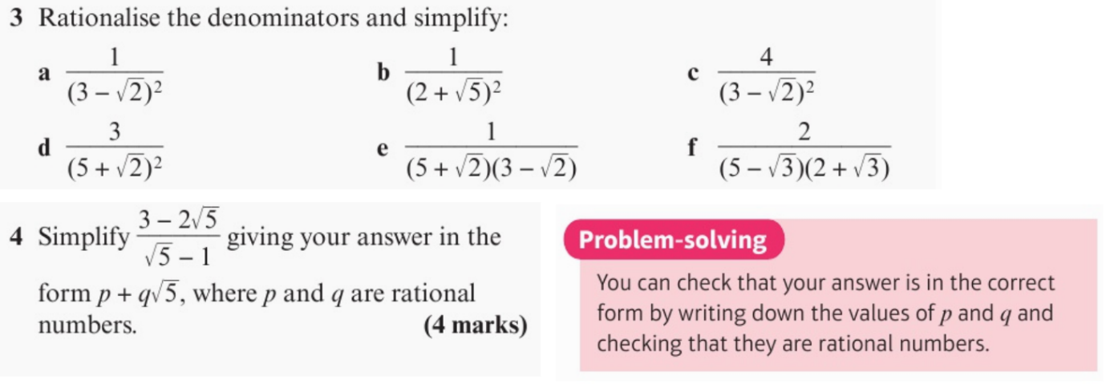

Mixed Exercise 1 – Review – ANSWER ALL QUESTIONS
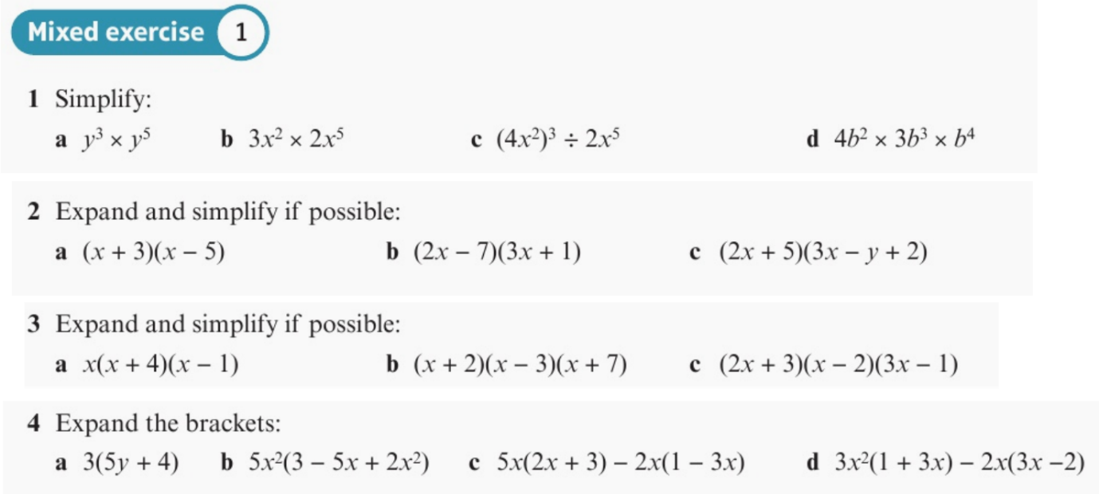
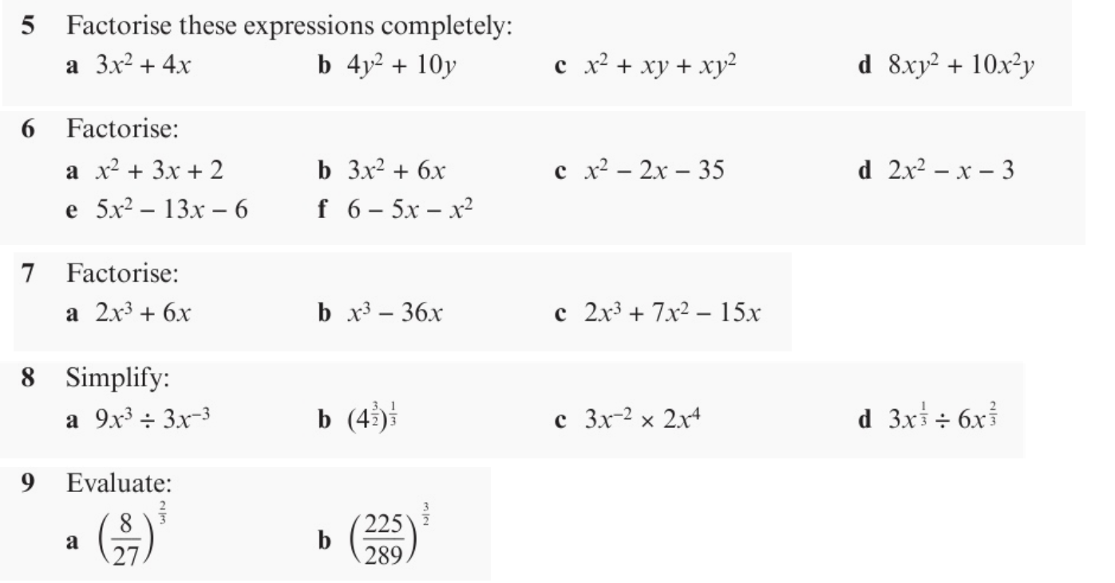
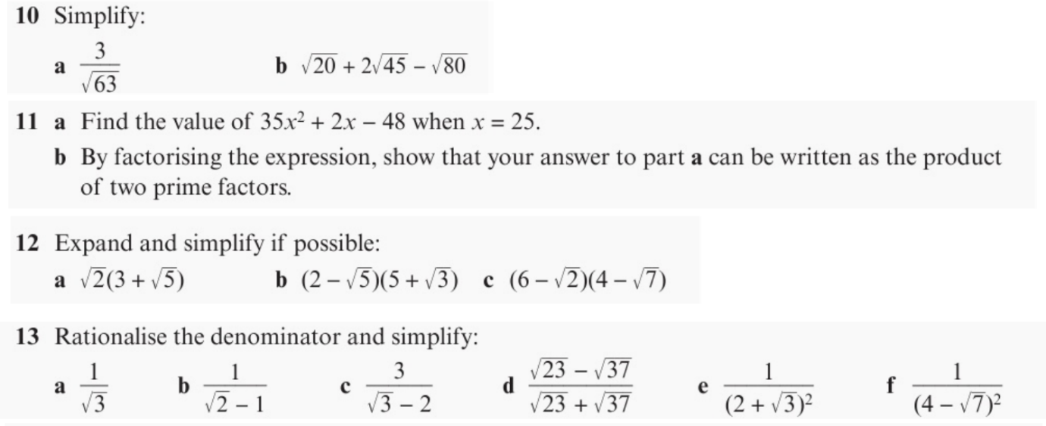

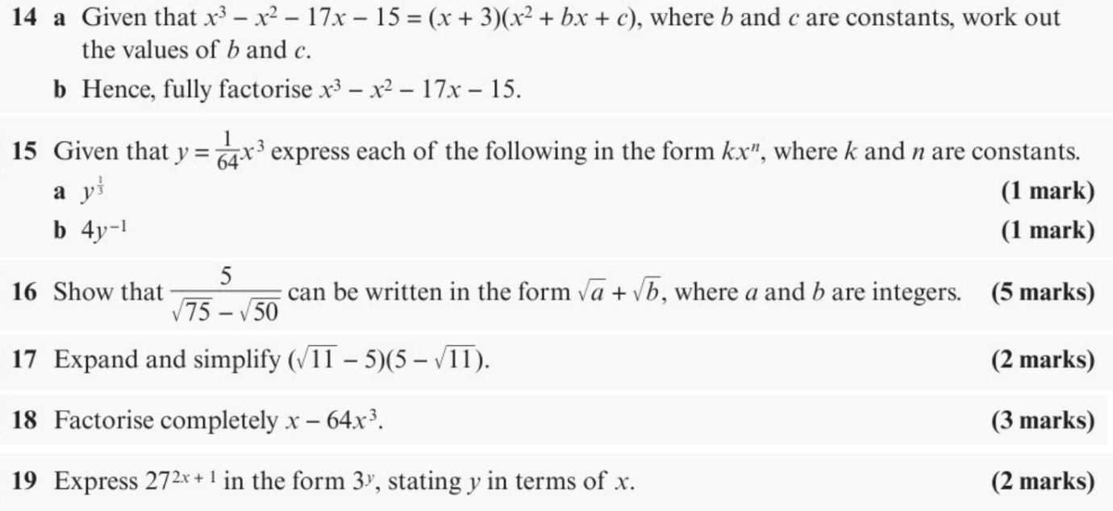
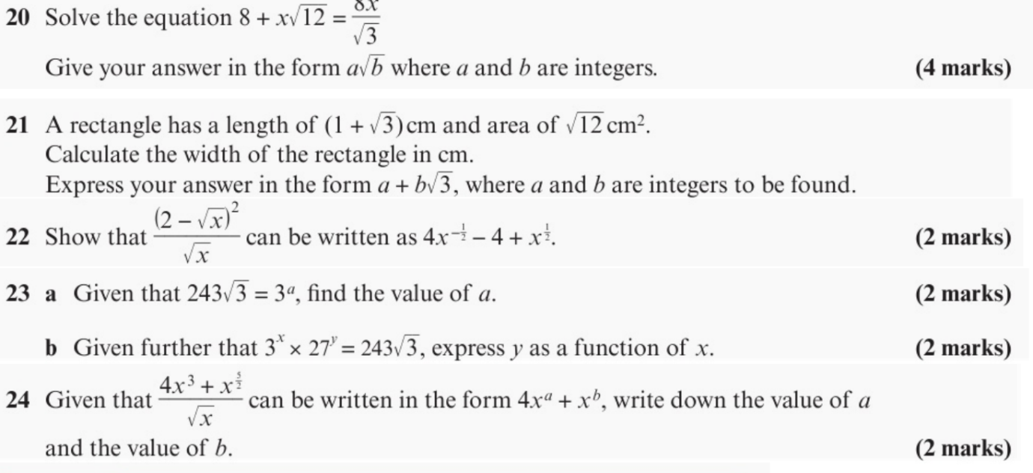

Year 12 Transition Work – Maths – Go Further…

If you are looking for things to do outside of the A Level course to further your knowledge and understanding then have a look at the resources below…

