|  |  |
| --- | --- |
| *<https://www.historyextra.com/period/stuart/stuart-britain-what-was-life-like-for-ordinary-people/>*  [*http://bcw-project.org/church-and-state/second-civil-war/prides-purge*](http://bcw-project.org/church-and-state/second-civil-war/prides-purge)  *A Anderson, Stuart Britain, 1603-1714, Hodder Murray, 1999*  *B Coward, Stuart England, 1603-1714, Longman, 1997*  *T Harris, Restoration, Penguin, 2006*  *J Morrill, Stuart Britain: A Very Short Introduction, Oxford University Press, 2000*  *D Scarboro, England, 1625-1660, Hodder Murray, 2005*  **What can you read? What can you watch?**  **How to prepare for A-Level History:**  **Stuart Britain, 1603-1702**  **What can you listen to? What else?** | *Gunpowder* (BBC 1)  *The Devil’s Whore* (All 4)  *Charles I: Downfall of a King* (BBC 4)  *Monarchy with David Starkey: The Stuarts*  *The Stuarts* (BBC 2)  *British History’s Biggest Fibs with Lucy Worsley: The Glorious Revolution* (BBC)  [*http://stuarts-online.com/resources/films/hamlet-and-the-jacobean-succession/*](http://stuarts-online.com/resources/films/hamlet-and-the-jacobean-succession/)  [*https://www.youtube.com/watch?v=dOGsrRw60oI*](https://www.youtube.com/watch?v=dOGsrRw60oI) |
| *Ridiculous History: How Oliver Cromwell got executed!*  *The Glorious Revolution (*BBC Radio 4)  *The rise of Puritanism,* [*https://podtail.com/en/podcast/history-extra-podcast/the-gunpowder-plot/*](https://podtail.com/en/podcast/history-extra-podcast/the-gunpowder-plot/)  *Charles I’s early reign,* [*https://www.historyextra.com/period/stuart/spooky-stuart-ghost-stories/*](https://www.historyextra.com/period/stuart/spooky-stuart-ghost-stories/)  *Dan Snow’s History Hit podcasts* (Spotify)  *Early Stuart Britain* (Player FM)  *Historical Association: The voice for History* | [*https://fdslive.oup.com/www.oup.com/oxed/secondary/history/A%20Level%20History%20Learning%20from%20home%20pack.pdf?region=uk*](https://www.google.com/url?q=https://www.google.com/url?q%3Dhttps://fdslive.oup.com/www.oup.com/oxed/secondary/history/A%252520Level%252520History%252520Learning%252520from%252520home%252520pack.pdf?region%253Duk%26amp;sa%3DD%26amp;ust%3D1587104150188000&sa=D&ust=1587104150262000&usg=AFQjCNHACu-EJm91F9gp6JVfvwO0s1uYsg)  *BBC History magazine (released monthly)*  *CGP introduction (free on Amazon for Kindle)*  *Smithsonian magazine*  ***Courses you could complete***  [*https://www.open.edu/openlearn/tags/stuarts*](https://www.open.edu/openlearn/tags/stuarts)  ***Oxford University Press Transition pack***  ***History video channels***  *TEDEd – assorted History lessons*  *BBC teach History playlist* |

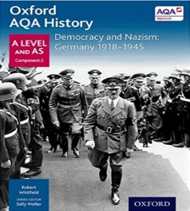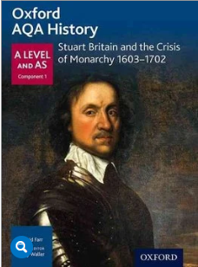

**Course Information**

The A-Level course comprises of units 1D (Stuart Britain and the crisis of Monarchy, 1603-1702) and 2O (Democracy and Nazism, 1918-1945) from the AQA qualification. We recommend that you purchase these as they have proven to be the most popular with students.