|  |  |
| --- | --- |
| The Hitler Myth: Image and Reality in the Third Reich by Ian Kershaw  Rise and Fall of the Third Reich by William Shirer  Weimar Germany: Promise and Tragedy  by Eric D. Weitz  Wolf Among Wolves, a Novel by Hans Fallada  Berlin Stories by Robert Walser  <https://alphahistory.com/weimarrepublic/>  <https://alphahistory.com/nazigermany/>  **What can you read? What can you watch?** | *The rise of Evil* (Youtube)  *Nazis a warning from History (BBC*)  Cabaret (youtube)  Hitler: a Career  Sophie Scholl: The Final Days  Schindler’s List  The Pianist  **What can you listen to? What else?** |
| *Dan Snow’s History Hit podcasts* (Spotify)  History Rocks podcasts  *Historical Association: The voice for History* | *BBC History magazine (released monthly)*  *CGP introduction (free on Amazon for Kindle)*  ***Courses you could complete***  <https://www.open.edu/openlearn/history-the-arts/history/erzberger-negotiating-the-armistice-germany>  <https://www.open.edu/openlearn/history-the-arts/history/world-history/the-holocaust/content-section-0?active-tab=description-tab>  <https://www.open.edu/openlearn/history-the-arts/the-american-civil-rights-movement/content-section-0?active-tab=description-tab>  ***History video channels***  *TEDEd – assorted History lessons*  *BBC teach History playlist* |

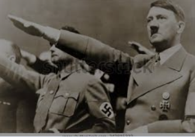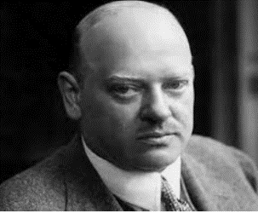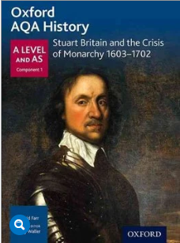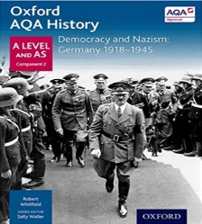

**How to prepare for A-Level History:**

**Germany 1919 - 1945** : **Democracy and Dictatorship**

**Course Information**

The A-Level course comprises of units 1D (Stuart Britain and the crisis of Monarchy, 1603-1702) and 2O (Democracy and Nazism, 1918-1945) from the AQA qualification. We recommend that you purchase these as they have proven to be the most popular with students.