OCR Cambridge Technical Sport and Physical Activity:
Bridging Booklet

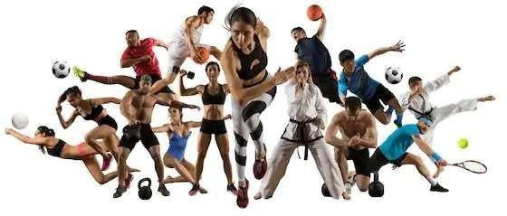
Name:

Submission Deadline:

Sport & fitness is a huge industry... and you can be part of it. If you’re keen on sport you can make a healthy living from your passion. From professional sport through to amateur teams and individuals who just want to get in shape, sport and fitness is a fast-growing business. This course leads nicely into higher education and best of all, you could be in a career doing something that you love.

PRE-OCR Cambridge Technical Sport and Physical Activity
COURSE MATERIALS & NOTES
Course Outline:
In Year 1, students will be study the 2 compulsary units. These are:-
- Unit 1: Body systems and the effects of physical activity (Exam)
- Unit 2 Sports Coaching and Leadership (course work)

In Year 2, students will complete the remaining 3 units. These are:-
- Unit 3: Sports Development and Organisation (Exam)
- Unit 8: Organising Sports Events (course work)
- Unit 17: Sports Injuries (course work)

Task 1: Follow the link below and download (do not print) a copy of the specification. Plan a coaching session for a sport of your choice to showcase you leadership skills when you start in Year 12.
RAG rate the skills for which skills you are competent at and which need development.
https://www.ocr.org.uk/Images/258725-sports-coaching-and-activity-leadership.pdf
Task 2: Follow the link below and print off for your file a list of the command words that will need to be familiar with in preparation for the course.
Cambridge Techncials Command verbs (ocr.org.uk)
Task 3: Use the internet and prior knowledge to answer the exam paper at the end of this document.
Task 4: Look carefully at the documentaries, podcasts and journals and use your time away from school to engage with as many as possible that you have access to.
Important dates:
January 2024 Unit 1 Exam
April-May 2024 Unit 2 Moderation will take place.
Resit Exams will take place in June.

Title | Where to watch it | What it’s about?
The Dawn Wall | Netflix | Legendary free climber Tommy Caldwell tries to get over heartbreak by scaling the Dawn Wall of El Capitan in Yosemite National Park.
Free Solo | All 4 | Professional rock climber Alex Honnold attempts to conquer the first free solo climb of famed El Capitan's 900-metre vertical rock face at Yosemite National Park.
Icarus | Netflix | When filmmaker Bryan Fogel sets out to uncover the truth about doping in sports, a chance meeting with a Russian scientist transforms his story from a personal experiment into a geopolitical thriller.
The Class of ‘92 | YouTube | Cinematic documentary examining the rise to prominence and global sporting superstardom of six supremely talented young Manchester United footballers - David Beckham, Nicky Butt, Ryan Giggs, Phil Neville, Paul Scholes and Gary Neville.
Sunderland ‘Till I Die | Netflix | The English city of Sunderland has seen its main industries of shipbuilding and mining fall by the wayside, which means the Sunderland Association Football Club -- SAFC -- has become an increasingly more important part of the lifeblood of the unique city.
Pumping Iron | Netflix | This partly real and partly scripted film documents what many consider to be the golden age of bodybuilding that occurred in the 1970s.

Wider engagement in Physical Education
For all A Level Physical Education students it is also recommended that they actively seek to watch some of the many exceptional sporting documentaries that can be found on YouTube, Netflix, Amazon Prime or other online platforms. Recommendations include, but are not limited to:

Highlight the titles when you have watched, listened to and/read them

Documentaries

Title | Where to watch it | What it’s about?
Iron Cowboy | Amazon Prime | The Story of the 50.50.50 Triathlon is the true story James Lawrence's (aka the Iron Cowboy) herculean 50-day journey to complete 50 Ironman distances in 50 consecutive days in all 50 states as he redefines the limits of what is humanly possible.
Eliud | YouTube | Our short film from inside Eliud Kipchoge's training camp, that explores the philosophies that have made him the greatest marathon runner of all time.
The Man With The Halo | YouTube | The Man with the Halo – A story of bravery and determination in the face of adversity.
Nike: Breaking 2 | YouTube | Breaking2 was a project by Nike to break the two-hour barrier for the marathon.
Kissed by God | Amazon Prime | Three-time world champion surfer Andy Irons quietly battled bipolar disorder and opioid addiction throughout his life - demons that millions of others combat daily. His previously untold story tears down myths associated with the diseases.
The Edge | Amazon Prime | Between 2009 and 2013, the England Test cricket team rose from the depths of the rankings to become the first and only English side to reach world number one (since ICC records began). The Edge is a compelling, funny and emotional insight into a band of brothers' rise to the top, their unmatched achievements and the huge toll it would take.
Breaking 60 | Amazon Prime | Exploring the world of extreme running, as athletes take on the Hong Kong Four Trails challenge and attempt to complete all 298km in 60 hours. The challenge spans the entire width of Hong Kong, and is equivalent to seven marathons back-toback.
Game Changers | Netflix | James Wilks travels the world on a quest for the truth about meat, protein, and strength. Showcasing elite athletes, special ops soldiers, and visionary scientists to change the way people eat and live.

Title | Where to watch  it | What it’s about?
The Test | Amazon Prime | The Test: A New Era for Australia’s Team, is a docuseries following the Australian Men’s Cricket Team, offering a behind-the-scenes look at how one of the world’s best cricket teams fell from grace and was forced to reclaim their title and integrity.
Tyson - The Movie | Amazon Prime | Through a mix of interviews and archive film, the legendary boxer reveals his rollercoaster life. The film takes us from Tyson's early days in Brooklyn through his meteoric boxing career and subsequent lost fortune. We see a complex man, destroyed by his own hubris  - a modern-day Greek tragedy.
All or Nothing Manchester City | Amazon Prime | In this ground-breaking docu-series, follow Manchester City behind the scenes throughout their Premier League winning, record- breaking ‘17-18 season. Get an exclusive look into one of the best global sports clubs, including never-beforeseen dressing room footage with legendary coach Pep Guardiola, and delve into the players’ lives off and on the pitch.
The English Game | Netflix | Two 19th-century footballers on opposite sides of a class divide navigate professional and personal turmoil to change the game — and England — forever.
All or Nothing  Brazil National  Team | Amazon Prime | The Brazilian National Team goes on a journey of faith, brotherhood, and hard work to reimagine their identity and to reengage a disgruntled fanbase as they attempt to win the 2019 Copa América on home soil. From the locker room, trough the trainings, to the games, we go exclusively behind-the-scenes with the world’s most famous football team.
Michael Johnson:  Survival of the  Fastest | YouTube | Olympian Michael Johnson makes a personal genealogical and scientific journey to discover if African American and Caribbean athletes are successful as a result of slavery

Podcasts

Title | Where to find it | What it’s about?
The Science of Sport Podcast | Apple  Android | World-renowned sports scientist Professor Ross Tucker and veteran sports journalist Mike Finch break down the myths, practices and controversies from the world of sport. From athletics to rugby, soccer, cycling and more, the two delve into the most recent research, unearth lessons from the pros and host exclusive interviews with some of the world's leading sporting experts. For those who love sport.  Stand out episodes:  - 26/02/20 - The Science of Perfect Training  - 08/02/20 - The Shoe That Broke Running II  - 25/11/19 - Mary Cain & RED-S  - 23/10/19 - The Shoe That Broke Running  - 23/09/19 - Why the All Black Are The Greatest Sports Team  - 09/09/19 - How to Cheat at Sport and Get Away With It  - 27/08/19 - How to Make a Champion (Part II)  - 13/08/19 - How to Make a Champion (Part I)  - 09/07/19 - The Drugs In Sport Episode  - 18/08/19 - The Science of Cricket with Gary Kirsten  - 29/04/19 - Caster Semenya: Explaining Sex v Gender

Title | Where to find it | What it’s about?
That Triathlon Show | Apple  Android | The one triathlon show focusing on practical and actionable advice that you can use in your own triathlon training and racing. New episodes are released twice per week. Includes some excellent discussions on the science of training.  Stand out episodes:  - 06/02/20 - Hill repeats and long runs; Protein for endurance  - 27/01/20 - Race hydration, calories and sodium  - 06/01/20 - Volume, intensity and physiological adaptations  - 18/11/19 - Nutrition trends and current evidence  - 24/10/19 - Fueling workouts; Diet and body typs  - 14/10/19 - Improve your running speed, endurance and performance  - 03/10/19 - Aerobic and anaerobic capacity  - 19/09/19 - Does compression clothing improve performance and recovery

Title | Where to find it | What it’s about?
The Clean Sport Collective | Apple  Android | The Clean Sport Collective is a community of powerful voices comprised of athletes, brands, events, clubs, fans and the public to support the pursuit of clean sport and athletics through the absence of performance enhancing drugs.  Stand out episodes:  - 01/02/20 - New Shoe Regulations with Ross Tucker  - 26/01/20 - Evan Dunfee - Bronze Medalist in 50km walk  - 05/01/20 - Steve Magness, Nike Oregan Project Whistleblower  - 17/11/19 - Mary Cain Tells Us Her Story  - 20/10/19 - Tyler Hamilton: Convicted Doper and Whistleblower  - 07/10/19 - Kara and Adam Goucher on the 4-Year Bans  - 31/05/19 - Travis Tygart, CEO of USADA

Books, articles and journals

Title | Where to find it | What it’s about?
Touching The Void by Joe Simpson (1988) | Amazon | Simpson's harrowing account of his and Simon Yates's calamitous assault, in 1985, on Siula Grande, Peru, has rightly transcended the sport of climbing and become a legendary fable for what humans are capable of doing to survive. It centres, of course, on one of the most amazing escapes ever achieved: with Simpson hopelessly hanging off one end of a rope, Yates is faced with cutting it to prevent them both being killed. Somehow, Simpson survives the fall. But alone in a crevasse with a shattered leg, his situation is hopeless. What follows is a staggering tale of will and courage that also addresses the perennial question of what drives people to climb mountains in the first place. As Churchill said: "When you're going through hell, keep going".
SSN exercise & sports nutrition review  update: research & recommendations | https://jissn.biomed central.com/track/p  df/10.1186/s12970-  018-0242-y | This paper is an ongoing update of the sports nutrition review article originally published as the lead paper to launch the Journal of the International Society of Sports Nutrition in 2004 and updated in 2010. It presents a well referenced overview of the current state of the science related to optimization of training and performance enhancement through exercise training and nutrition. Notably, due to the accelerated pace and size at which the literature base in this research area grows, the topics discussed will focus on muscle hypertrophy and performance enhancement. As such, this paper provides an overview of: 1.) How ergogenic aids and dietary supplements are defined in terms of governmental regulation and oversight; 2.) How dietary supplements are legally regulated in the United States; 3.) How to evaluate the scientific merit of nutritional supplements; 4.) General nutritional strategies to optimize performance and enhance recovery; and, 5.) An overview of our current understanding of nutritional approaches to augment skeletal muscle hypertrophy and the potential ergogenic value of various dietary and supplemental approaches.

Title | Where to find it | What it’s about?
Peak Performance | Amazon | Peak Performance combines the inspiring stories of top performers across a range of capabilities from athletic to intellectual to artistic with the latest scientific insights into the cognitive and neurochemical factors that drive performance in all domains. Peak Performance presents the newly-discovered links that hold promise as performance boosters, but that have been traditionally overlooked. In a concise and relatable manner, Peak Performance explains the strong connection between mind and body and how everyone can apply certain techniques to enhance their own achievements. This book is an entertaining and actionable guide to optimising personal performance that shows readers how to get the most from themselves. Brad Stulberg and Steve Magness highlight great performers across various disciplines including Olympic marathoner Meb Keflezighi, three-time Grammy Award winner Don Was, and renowned mathematician David Goss. This book discusses the science and application of each principle of success and concludes with prescriptive techniques. Unlike other performance books that are field-specific, Peak Performance cuts across domains and will attract readers and entrepreneurs involved in diverse pursuits, from athletes to artists, from hobbyists to scientists, from students to business professionals. If you want to take your game to the next level, whatever 'your game' may be, Peak Performance will teach you how.

Section A
Put a tick (✓) in the box next to the one correct answer for each of questions 1 to 8.
- Which one of the following components of blood fights bacteria and viruses?
  - Plasma
  - Platelets
  - Red blood cells
  - White blood cells
[1]
- Which one of the following muscles causes flexion at the shoulder?
  - Deltoid
  - Latissimus dorsi
  - Pronator teres
  - Trapezius
[1]
- Which one of the following is not a fuel for the aerobic system?
  - Carbohydrates
  - Glucose
  - Lipids
  - Phosphocreatine
[1]
- Which one of the following is the correct order of air flow into the lungs?
  - Bronchiole → alveoli → bronchus
  - Bronchiole → bronchus → alveoli
  - Bronchus → trachea → alveoli
  - Trachea → bronchus → bronchiole
[1]
- Which one of the following correctly describes cardiac output?
  - Number of contractions of the heart per minute
  - Volume of blood pumped out of the atria per minute
  - Volume of blood pumped out of the heart per minute
  - Volume of blood pumped out of the ventricles per beat
[1]
- Which one of the following is not a benefit of a cool down?
  - Faster removal of lactic acid
  - Reduced blood pooling
  - Reduced flexibility
  - Reduced muscle soreness
[1]
- Which one of the following describes the concentration of a gas within a mixture of gases?
  - Diffusion gradient
  - Gaseous exchange
  - Internal respiration
  - Partial pressure
[1]
- Which one of the following describes the recovery process for the ATP-PC/alactic system?
  - Increases production of mitochondria
  - Involves removal of lactic acid
  - Involves restoration of glycogen
  - Takes two to three minutes
[1]
- Identify the gas produced as a by-product of the aerobic energy system.
................................................................................................................................................ [1]
- State the formula for calculating cardiac output (Q).
................................................................................................................................................ [1] Section B
- (a) Fig. 11 shows a diagram of the bones of the arm and hand.
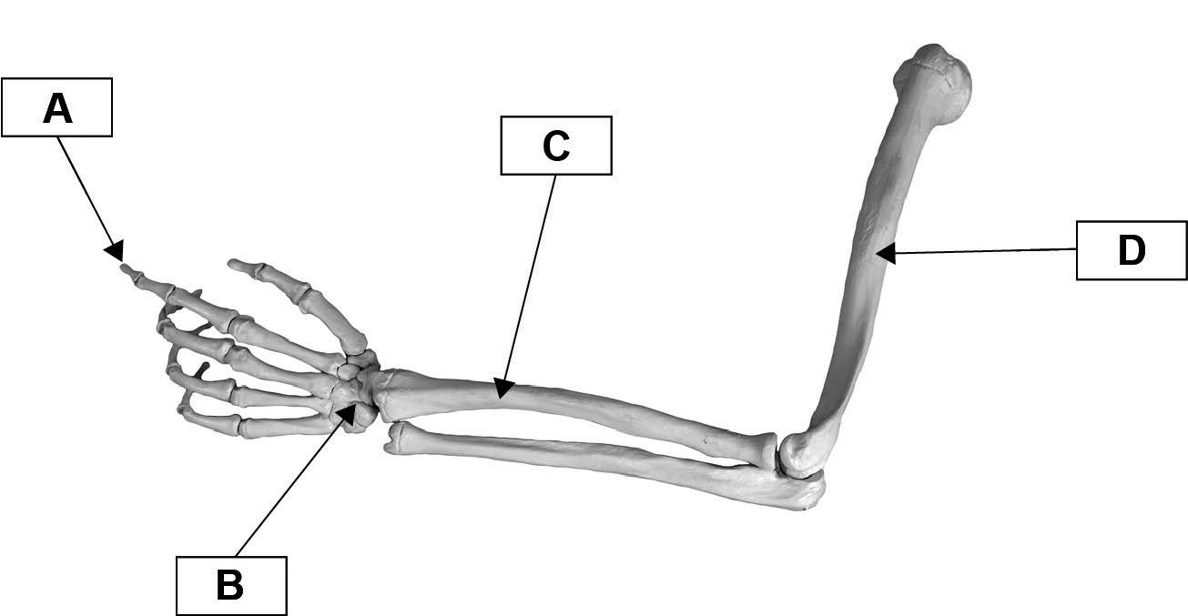

Fig. 11
Identify A, B, C and D on the diagram.
- ..........................................................................................................................................
- ..........................................................................................................................................
- ..........................................................................................................................................
- ..........................................................................................................................................
[4]
(b) Complete the table to identify the joint movements in the practical examples.
Joint movement | Practical example
..................................................... | Knee: Bending the knee in preparation to jump.
..................................................... | Shoulder: Making circles with the arm to warm the shoulder muscles up.
..................................................... | Ankle: Pointing the toes during a handstand.
[3]
12 Fig. 12 shows the major skeletal muscles of the leg.
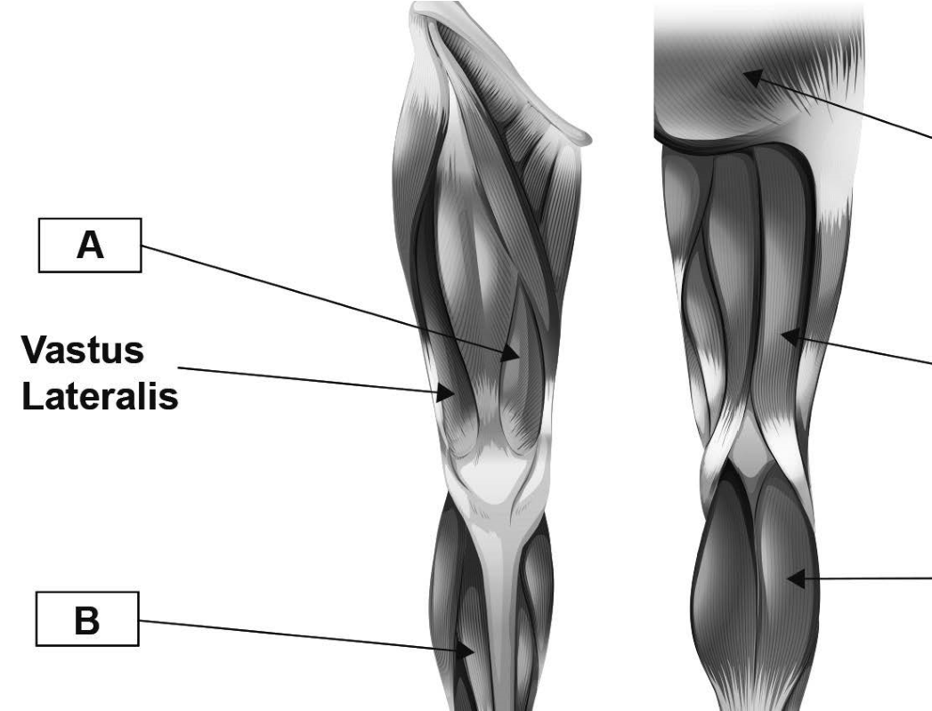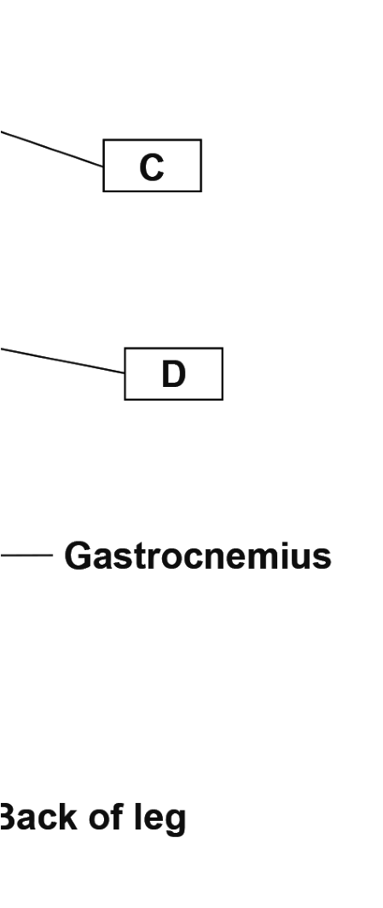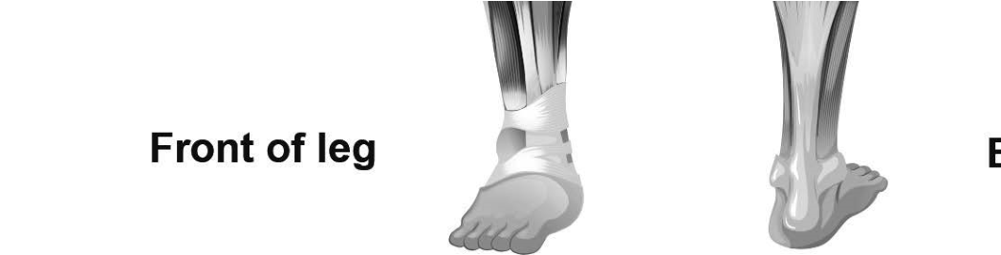

Fig. 12
Identify the muscles labelled A, B, C and D.
- ..................................................................................................................................................
- ..................................................................................................................................................
- ..................................................................................................................................................
- ..................................................................................................................................................
[4]
13 Fig. 13 shows the upward phase of a pull up.
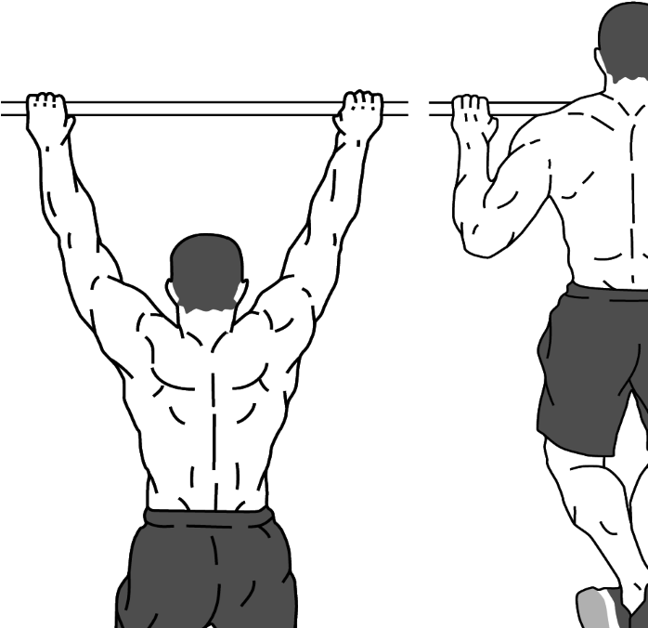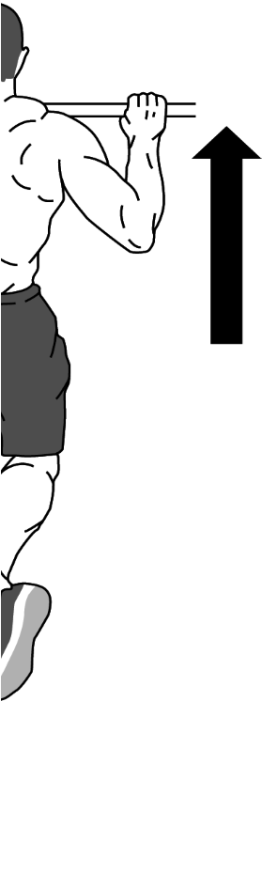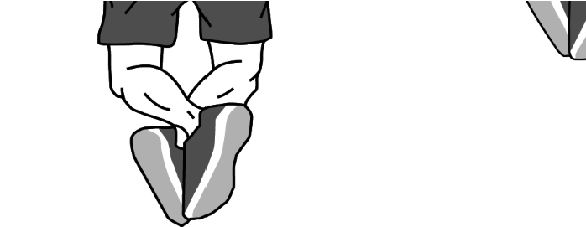

Fig. 13
Complete the table to analyse the movement at the elbow and wrist during the upward phase of the pull up.
Joint | Muscle function | Muscle acting | Type of muscle contraction
Elbow | Agonist | ............................................. | .............................................
Wrist | Fixator | Pronator teres | .............................................
[3]
- State which muscle fi bre type would be mainly used in the following activities:
400 m race in athletics .................................................................................................................
10 km walking race ......................................................................................................................
Tennis smash ...............................................................................................................................
50 m swimming race .................................................................................................................... [4]
- Describe four short-term effects of exercise on the muscular system.
  - ...................................................................................................................................................
.....................................................................................................................................................
  - ...................................................................................................................................................
.....................................................................................................................................................
  - ...................................................................................................................................................
.....................................................................................................................................................
  - ...................................................................................................................................................
.....................................................................................................................................................
[4]
- Complete the table to identify and describe the function of various structures of the heart.
Structure | Function
Bicuspid valve | 1.....................................................................................  .......................................................................................  .......................................................................................
2...................................................... | This chamber receives blood from the pulmonary vein.
3...................................................... | The walls of this chamber contract to pump deoxygenated blood to the lungs.
Vena cava | 4.....................................................................................  .......................................................................................  .......................................................................................
5...................................................... | This valve closes to prevent blood flowing back into the left ventricle.
[5]
- (a) Outline three differences between arteries and veins.
  - ...........................................................................................................................................
.............................................................................................................................................
  - ...........................................................................................................................................
.............................................................................................................................................
  - ...........................................................................................................................................
.............................................................................................................................................
[3]
(b) As blood leaves the heart it passes through a series of blood vessels.
Other than arteries and veins, identify three different types of blood vessel in the body.
  - ...........................................................................................................................................
  - ...........................................................................................................................................
  - ...........................................................................................................................................
[3]
- (a) The sentences below describe the mechanics of breathing during inspiration.
Complete the sentences by filling in the missing words.
The ………....…......………....…........... and ………....…......………....…...........
………....…......………....…........... muscles contract.
The ………....…......………....…........... move(s) upwards and outwards.
The volume of the ………....…......………....…...........
………....…......………....…........... increases.
This causes pressure in the lungs to ………....…......………....…........... .
Air is drawn into the lungs.
[5]
(b) Fig. 18 shows a graph of minute ventilation before, during and after sub-maximal exercise.
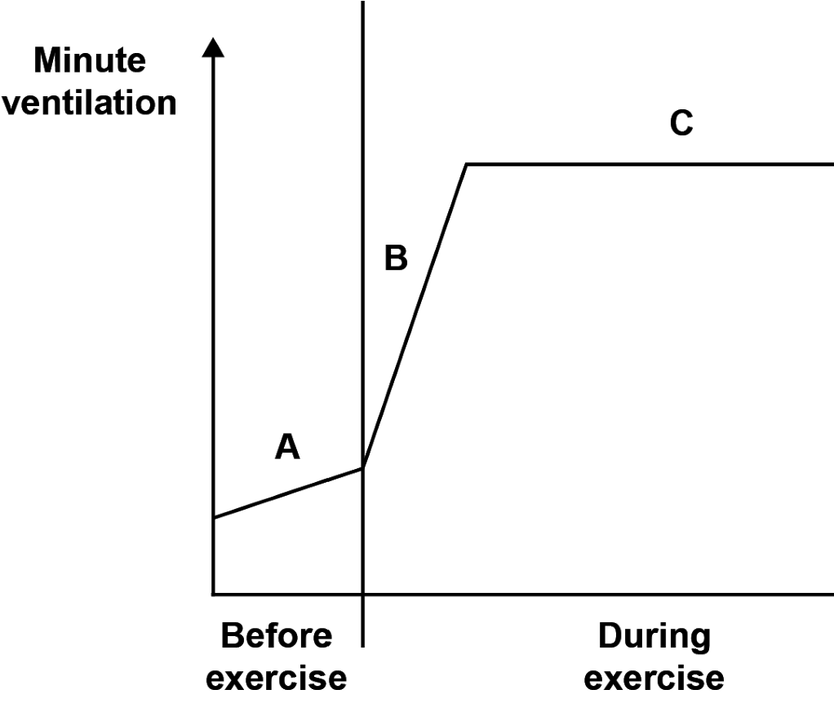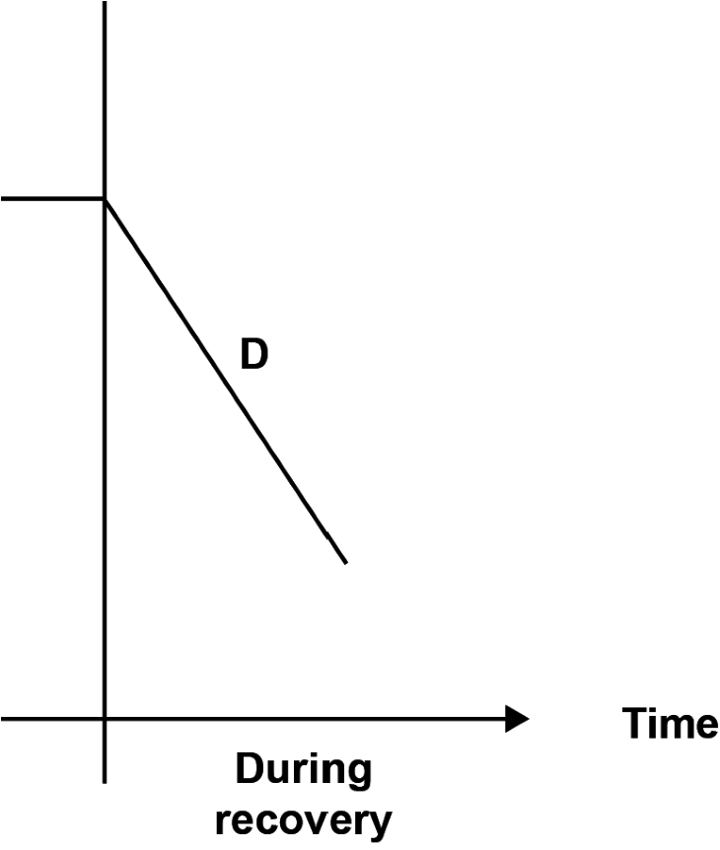

Fig. 18
Explain the changes in minute ventilation before exercise, during exercise and during recovery.
- - Before exercise
.............................................................................................................................................
............................................................................................................................................. .............................................................................................................................................
- - Initial increase during exercise
.............................................................................................................................................
............................................................................................................................................. .............................................................................................................................................
- - Steady-state plateau during exercise
.............................................................................................................................................
............................................................................................................................................. .............................................................................................................................................
- - During recovery
.............................................................................................................................................
.............................................................................................................................................
............................................................................................................................................. [4]
- Describe three long-term effects of regular exercise on the respiratory system.
  - ...................................................................................................................................................
.....................................................................................................................................................
  - ................................................................................................................................................... .....................................................................................................................................................
  - ...................................................................................................................................................
.....................................................................................................................................................
[3]
- (a) Fig. 20 shows an example of an energy continuum.

Fig. 20
Show your knowledge of energy systems by placing the letters A, B and C to show where each of the following sporting activities would be on the energy continuum:
- Gymnastics floor routine
- Discus throw
- 10 km swim.
[3]
(b) Justify your placement of B and C on the energy continuum.
.............................................................................................................................................
.............................................................................................................................................
.............................................................................................................................................
.............................................................................................................................................
.............................................................................................................................................
........................................................................................................................................ [2]

Section C
21* The skeleton is made up of several types of bone. Short bones are one example.
Explain the functions of the skeleton and how they link to different types of bone.
Your answer should include:
- an explanation of the functions of the skeleton
- a description of the different types of bone (e.g. short bones) • the functions of each type of bone, using examples of named bones.
[10]
.....................................................................................................................................................
.....................................................................................................................................................
.....................................................................................................................................................
.....................................................................................................................................................
.....................................................................................................................................................
.....................................................................................................................................................
.....................................................................................................................................................
.....................................................................................................................................................
.....................................................................................................................................................
.....................................................................................................................................................
.....................................................................................................................................................
.....................................................................................................................................................
.....................................................................................................................................................
.....................................................................................................................................................
.....................................................................................................................................................
.....................................................................................................................................................
.....................................................................................................................................................
.....................................................................................................................................................
.....................................................................................................................................................
.....................................................................................................................................................
.....................................................................................................................................................
.....................................................................................................................................................
.....................................................................................................................................................

